Issue with basis fitting to data

Data:
TE = 35ms
Dwelltime/Bandwidth = 1200 Hz
Field Strength = 2.90 T

Basis set:
Press Siemens
TE = 35ms
Dwelltime/Bandwidth = 2500 Hz
http://juchem.bme.columbia.edu/mr-spectroscopy-basis-sets

First attempt with a 2500 Hz basis set was unsuccessful, and we received an error regarding the basis spectra covering too little time. Converted the basis to a 1200 Hz bandwidth and a 2.90 T field strength, which solved the error. However, the model fit was not good. Also attempted a 600 Hz bandwidth (half of the Hz of the original data), this produced a VERY badly fitting model. Neither of these attempts produced much concentration data, there were a lot of concentrations that read 0 or null.

MRI scanner data processed using (done in a shell script):
- Conversion of dicoms to nifti [spec2nii dicom -f converted_${b} *.dcm]
- Eddy correction for both water and water supressed [fsl_mrs_proc ecc --file *d_${p[@]}.nii.gz --reference *w_${p}.nii.gz --output fsl_mrs_proc -r --filename ecc_metab_${p[@]}]
- Centring the echo for both water and water supressed [fsl_mrs_proc truncate --file *metab_${t[@]}.nii.gz --points -1 --pos first --filename trunc_metab_${t[@]} --output fsl_mrs_proc2 -r]
- Residual water for water supressed [fsl_mrs_proc remove --file trunc_metab_${y[@]}.nii.gz --output fsl_mrs_proc3 -r --filename hlsvd_metab_${y[@]}]
- Phase correction for both water and water supressed [fsl_mrs_proc phase --file hlsvd_metab_${h[@]}.nii.gz --output fsl_mrs_proc4 -r --filename final_metab_${h[@]}]

Basis and data fitting were without error but the fit was not great.
svs_segment -t *${t}.nii.gz ~/spec_analysis/converted_${t}.nii.gz -o $homed15/*json_${t} -f ${t}

fsl_mrs --data fitting/final_metab_${e}.nii.gz --basis ~/Basis –output fitting/fsl_mrs_fit_data_${e} --t1 T1/MR_T1_MPRAGE_${e}.nii.gz --tissue_frac json/json_${e}/${e}_segmentation.json --h2o fitting/final_wref_${e}.nii.gz --report

fsl_mrs_preproc command would not work – there was an error that the data had already had some pre-processing done (despite being advised that none had been done at the clinic) and so this is why each command was done separately. Specifically, the individual processing steps that didn’t work were:
- The twix commands
- DIM_DYN and split visualisation commands
- Averaging of the water reference data
- No coil combination
- No alignment
- No data averaging

We also attempted to do processing on the basis, which created a better fit but still not perfect. This processing produced results, but some of the last steps in the processing made the fit worse despite increasing the amount of non-zero metabolite concentration values available. These were the steps used to process the basis (essentially followed the instructions on the forum):

basis_tools convert RawBasis_for_PRESSSiemens_TE_35_BW_2500_NPts_1024 --bandwidth 1200 --fieldstrength 2.9 basis_1200

mkdir fsl_basis_reduced

cd basis_1200

cp Tau.json... etc ../fsl_basis_reduced

cd ..

mrs_tools vis fsl_basis reduced

At this point upon visualising the basis, all of the metabolites were sitting on the far left of the x-axis and not centred like in the example basis. However, we still continued processing to see how the fit would come out. The fit was slightly better at this stage.

basis_tools add_set –add_MM fsl_basis_reduced fsl_basis_with_MM

cd fsl_basis with_MM

mkdir mmbits

mv MM* mmbits/

basis_tools conj mmbits

At this point we produced a fitting again with the same code as earlier – the fitting was slightly better.

- Added -- metab_groups MM09 MM12 MM14 MM17 MM21 into the code.

This improved the fit slightly. Still not great and still getting 999 values.

- Added -- baseline_order -1
- Added -- algo MH

After doing this all concentration values were available, however, the fit slightly worsened again.

After this we attempted to conjugate the basis again – this made no difference.

We also attempted to shift the basis (all values) by -2ppm and -1ppm.
This showed some improvements; however, it wasn’t clear how far it needed to be moved and resulted in a lot of bunching of data on the right side rather than the left.

To fix this, we attempted to scale individual metabolites to their correct locations based using the scaling feature. However, this didn’t appear to make any difference.

Lastly, we attempted to shift individual metabolites by guesswork with the shift command – this also didn’t produce any substantial improvement.

This was the best result with the basis set after most of the processing above (1200hz, baseline order, MM, algo) and the baseline itself at different phases.

Basis after initial convert function to 1200hz:
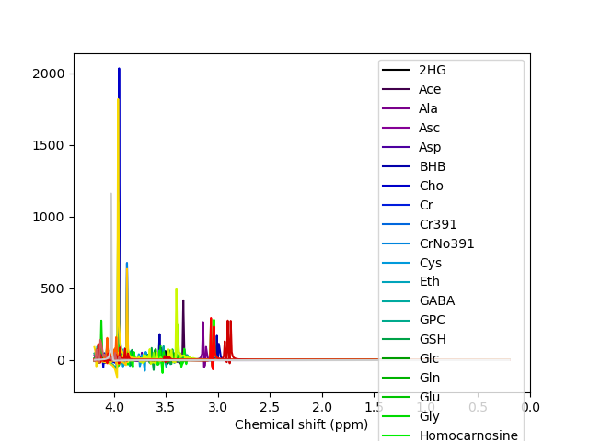

Fitting at this stage:
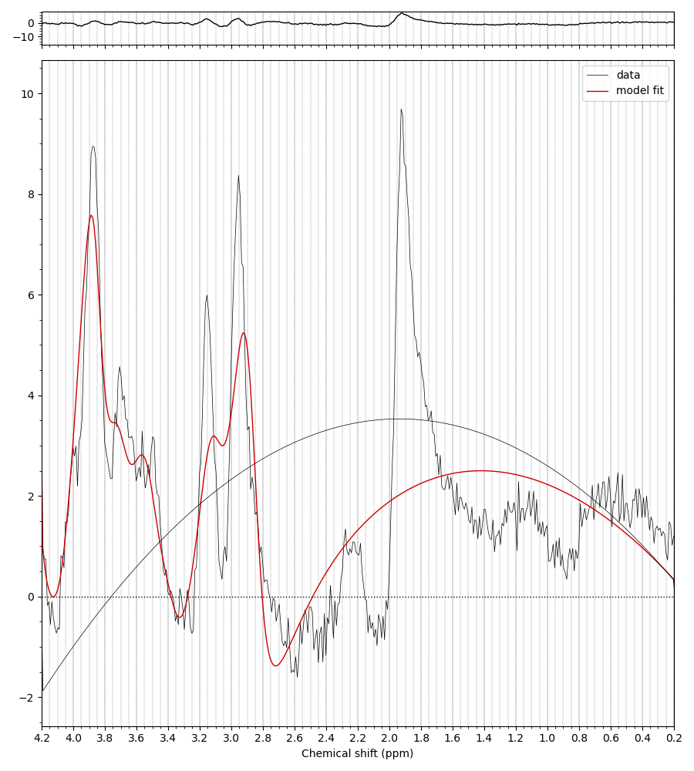

Basis after making reduced basis:
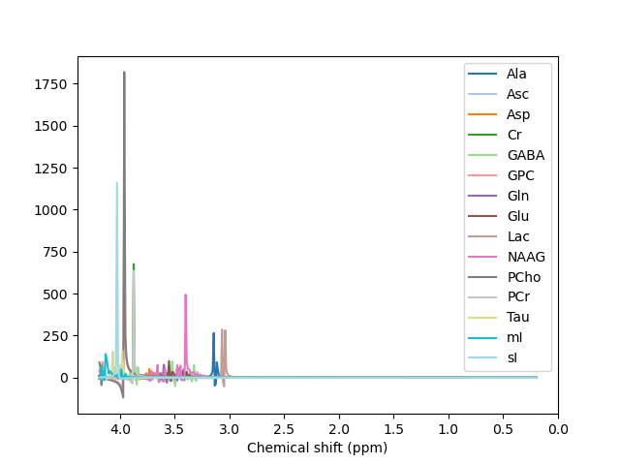

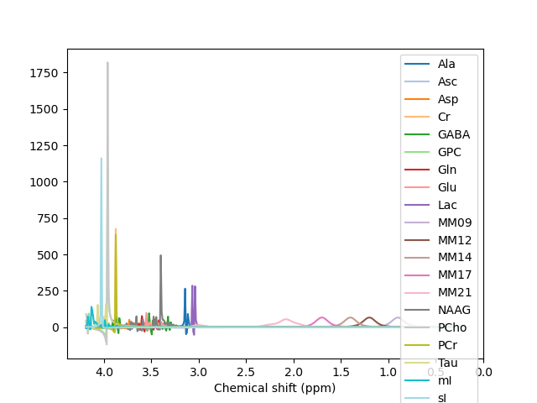
Basis after MM:

Fitting with just MM (data values were missing here):

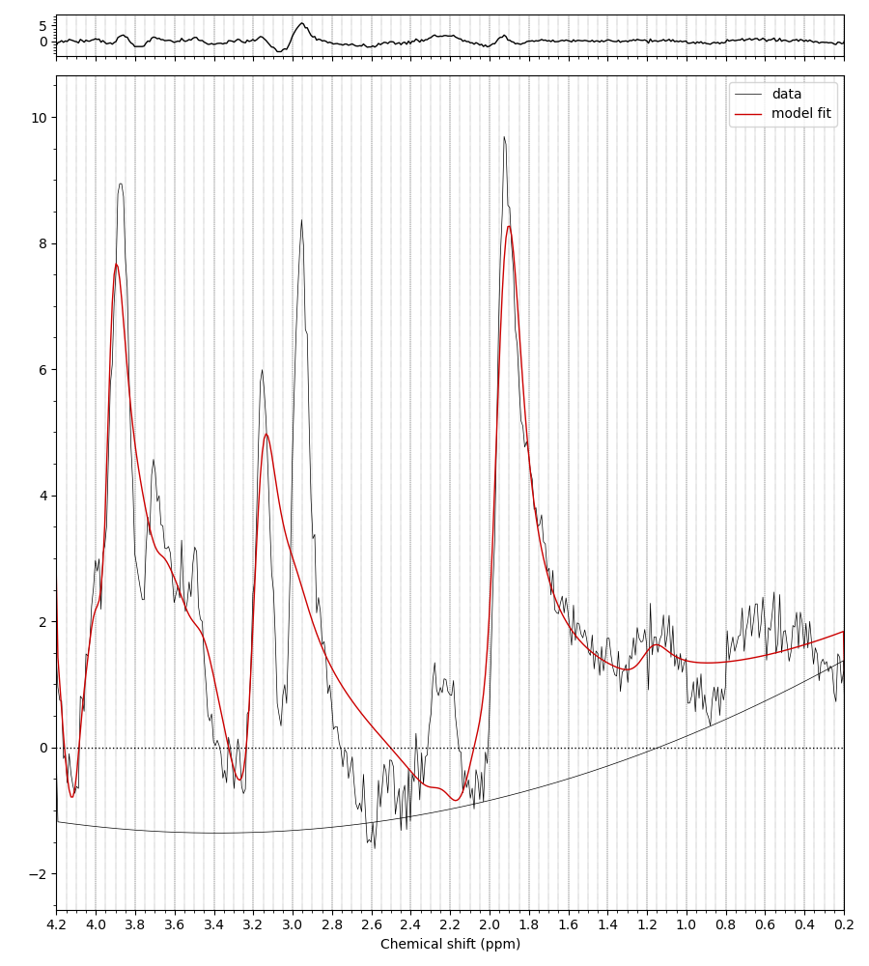

Fitting with MM, flexibility, and algo (all of the concentration data was available here but the fitting was worse);

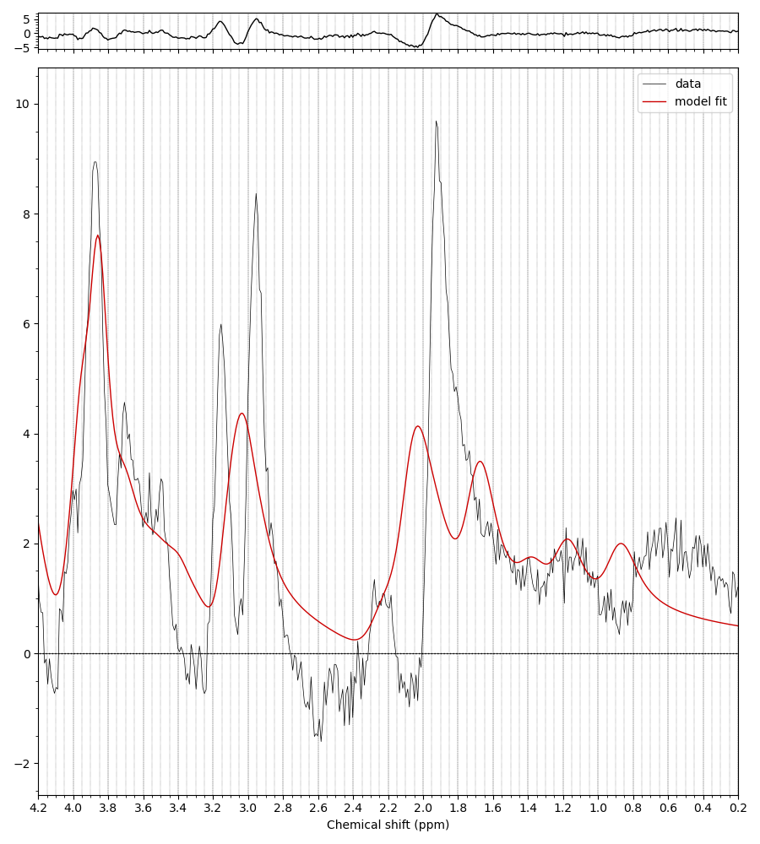

This was the fit without the algo command but with the baseline flexibility command – it appeared to give the best fit, but there were still data values missing including glutamate and GABA, both ones we needed:

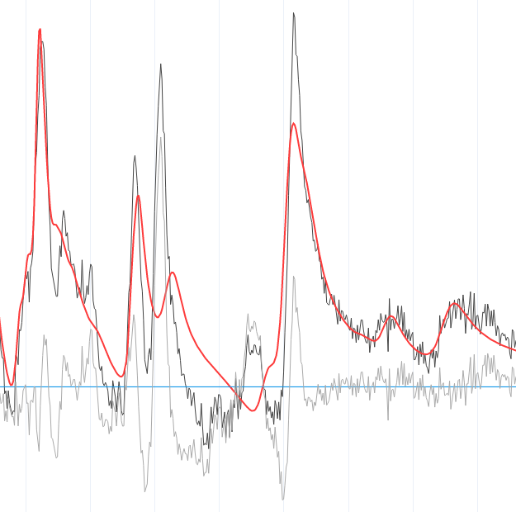

This was the second best fit which was inclusive of the algo command but not the baseline command. Data was available for this one for all of the metabolites, however the fit isn’t amazing:

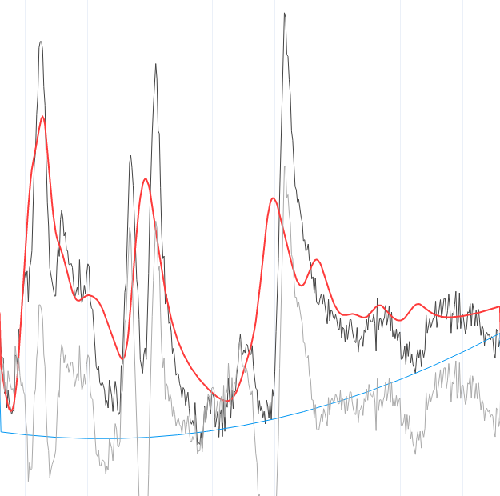

Shifting/scaling just produced the same sort of results with metabolites shifted to the right/left. It didn’t appear to be a good solution.

